**Result File Manual**

Team 3 | 2020

**Using Data Analytics Extracts Top Keywords and Trends in Information Technologies**

V2

The Utility solution is a web scrapping tool that was developed for the Seidenberg Career Services at Pace University to envisage new career opportunities from the popular job markets. The tool enables the department to seamlessly enter keywords, extract data from popular job portals and analyze results for visualization. Based on predetermined top keywords, it performs data scrapping through a Python executable code in Google Colaboratory.

The output file, as the result file, allows users the ability to visualize the current trends of the popular job markets which supports both students as they seek employment through Career Services, and Pace University to use as a baseline for making strategic decisions about future program offerings. Once the Utility tool creates the output files and places them into the local or Google Drive location, open the files to copy over the data into a predefined Excel file with formulas for visualization. This is a manual process that enables the visuals. Our recommendation for the future enhancement is to automate the manual processes – especially the consolidated worksheets, formulas, and trends, by executing Excel Macro.

**STEP 1:** Open the output result file that was created by the Utility tool*-* please note, this file will be located on your local drive. Open the redefined Excel Workbook from the desired location.

*For example, if the output result file is for the Cybersecurity position, open the predefined file with the formula “Cybersecurity”.*

**STEP 2:** Copy the values from each of the last 5 worksheets *(Figure 1)* located within the output result file and paste them into the corresponding worksheets of the predefined Excel file.



**Figure 1**

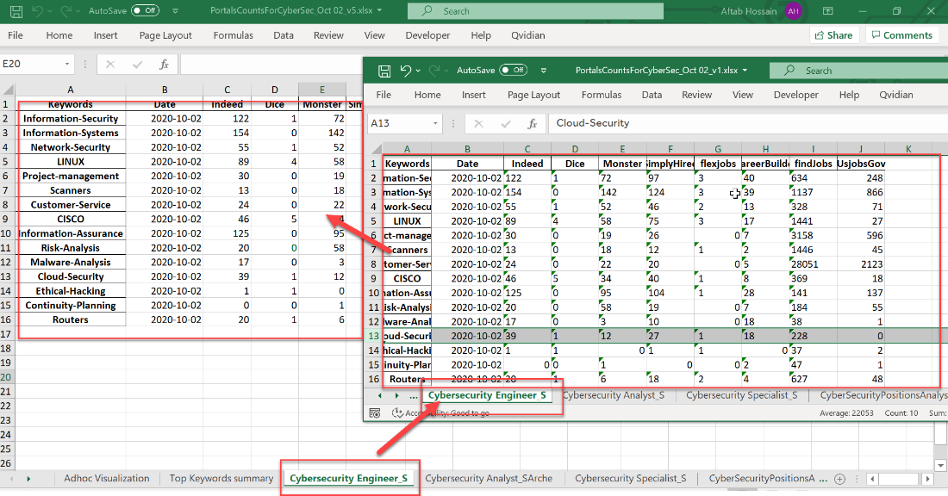

**Figure 2**

*For example, as shown above in Figure 2, copy the data from the Cybersecurity Engineer_S tab in the output result file and paste them into the Cybersecurity Engineer_S tab of the PortalsCountsForCyberSec worksheet.*

While you are copying data from the output result file into the predefined excel file, ensure that the value under the job portal columns are numeric. To do this, follow the steps shown below in Figure 3 *– highlight the cells and click on the drop-down arrow of the Alert icon to expand the options. Select “Convert to Number”.*

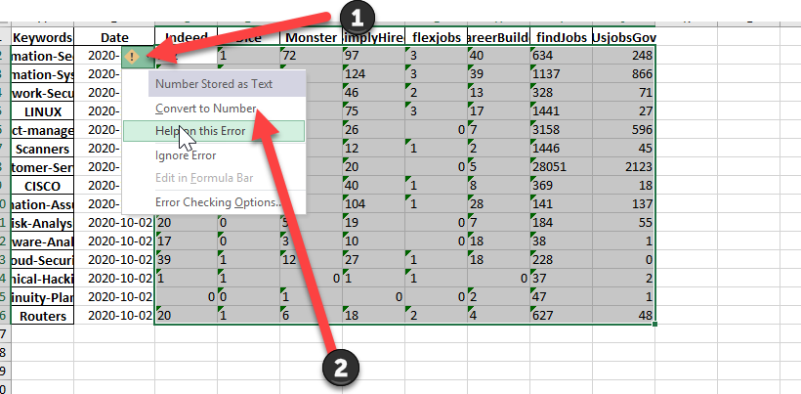

**Before**

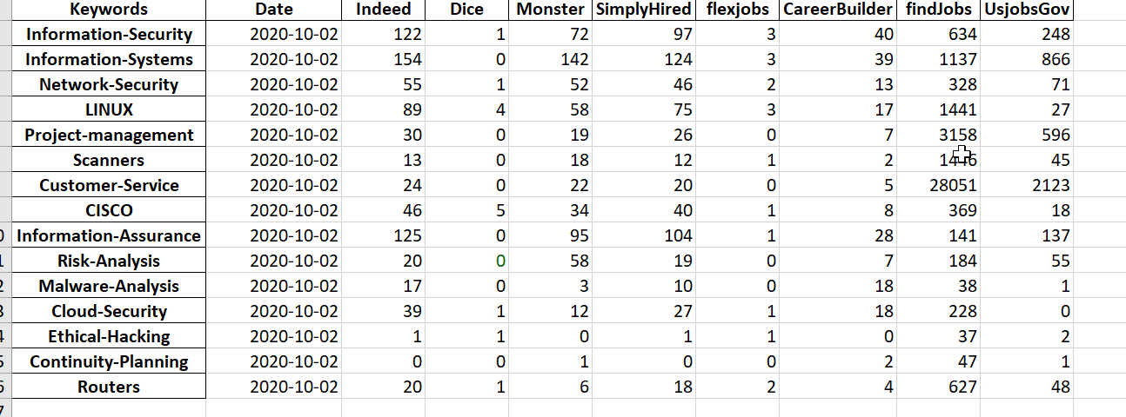

**After**

**Figure 3**

**STEP 3**: Open the “Top Keywords summary” worksheet from the Predefined file. Note that the date on the upper left-hand corner of the tables worksheet in Figure 4, is the same date as on the output result file shown in Figure 3. The embedded formula in each of the tables *(Figure 4)* calculates the value from the corresponding worksheet to display the top 10 skills by count in the first column of the popular job portals (i.e. Indeed). The remaining columns match the keywords to display the counts. The top 10 numbers across the job portal columns are highlighted to show those in high demand.

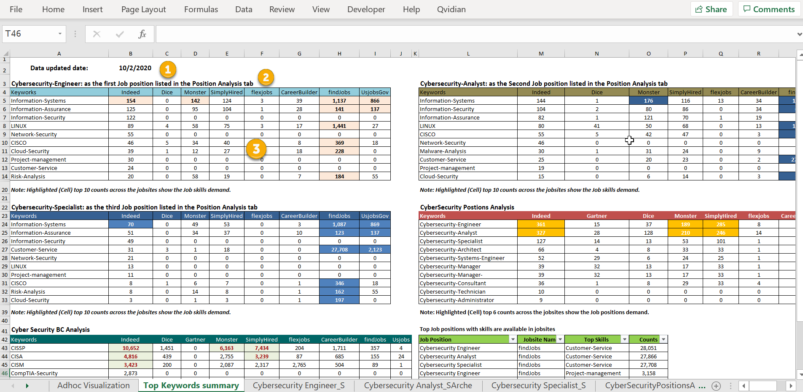

**Figure 4**

The top job positions with the corresponding top skills across the most popular job portals per count are shown below *(Figure 5)*.

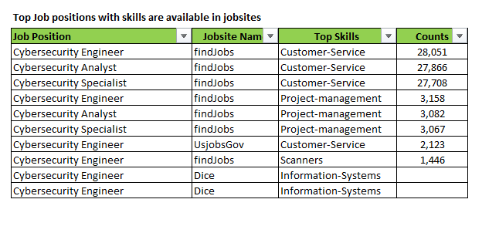

**Figure 5**

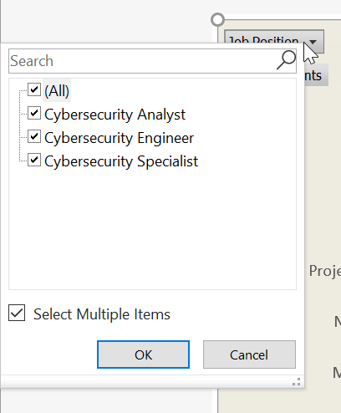**STEP 4:** Open the “Adhoc Visualization” worksheet from the predefined file. The Pivot graph *(Figure 6)* allows users to filter by Job position, Skills, and/or Jobsite Name to show the corresponding trend.

*For example, clicking on the drop-down arrow from the Job Position, shows the multiple items one can select from. Similarly, other filters function based on the selection from the multiple items options as well.*

**Figure 6**

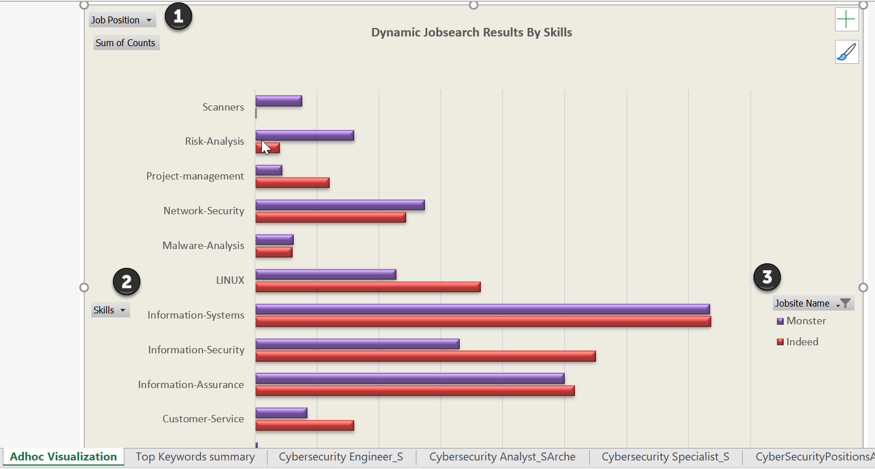

**Figure 7**

Figure 7, above, shows that the *Adhoc Virtualization and Top Keyworks summary worksheets of the predefined Excel file remain as is.*

***PLEASE ENHANCE THIS USER MANUAL AS NEEDED***